The collection

OF

AI STORIES

Made by the students of the group

|  |
| --- |
| M8O-306Б-20 |
| Lisin Roman |
| Maltsev Ivan |
| Frolov Mikhail |

Moscow, 2023

Contents

[The Foreword 2](#_Toc128254771)

[The Physics Exam Disaster 3](#_Toc128254772)

[Robert's Redemption 5](#_Toc128254773)

[The Life Thief 9](#_Toc128254774)

[A Magical Adventure to Sharm-el-Sheikh 11](#_Toc128254775)

[A Dreamer's Journey: Find the Better Place 13](#_Toc128254776)

[Soul Master 16](#_Toc128254777)

# The Foreword

It is with great pleasure that we introduce you to this collection of stories, generated by artificial intelligence. This book represents an exciting leap forward in the development of artificial intelligence, as it allows us to experience stories created by machines.  
 The stories in this collection were generated using state-of-the-art algorithms and techniques, and are sure to provide limitless hours of captivating reading. It is truly remarkable to think that these stories were generated without any human intervention.  
 This book stands as a testament to the power of artificial intelligence, and its potential to revolutionize the way we think about storytelling. It is a fascinating exploration of the possibilities of AI, and we are sure that you will be amazed by the results.  
 We are confident that this book will captivate you, and hope that it can inspire to explore the world of artificial intelligence further. Enjoy!



# The Physics Exam Disaster

Jim had always been a bit of a loner and a bit of an underachiever in school. He was never really motivated to do much and he had a hard time studying, so he didn't get the best grades. This caused him to get picked on by his fellow classmates and even some of his teachers.

Growing up, Jim never had a father figure in his life and he had a strained relationship with his mother. He was an only child and had no close friends.

When Jim was in high school, he was still struggling to stay afloat. He wasn't able to keep up with his studies and often found himself daydreaming in class. He was becoming increasingly frustrated with his lack of progress and was beginning to doubt his own abilities.

One day, Jim decided to challenge himself and sign up for a physics class. He was determined to prove to himself that he could do it and be successful. He worked hard and put in extra effort and was surprised to find that he was actually doing well in the class.

Jim's newfound enthusiasm for physics had him pushing himself even further to excel in the class. He started attending study groups and asking questions in class more often. He was feeling really good about himself, and was confident that he would ace the final exam.

The day of the final exam arrived and Jim was feeling ready and confident. He had studied hard and was sure that he would do well. He began to answer the questions on the exam, but soon realized that he was completely lost. He had no idea how to answer the questions and started to panic.

He tried to power through and finish the exam, but ended up getting more and more confused. He was overwhelmed and his thoughts were all over the place. In the end, he failed the exam.

When Jim got his grade back, he was devastated. He had worked so hard and had been hopeful, but it all seemed to be for nothing. He felt embarrassed and ashamed of himself.

He felt like a failure, and he was sure that everyone around him was judging him and laughing at him. He completely shut down and refused to talk to anyone about it. He was embarrassed about what had happened and didn't want anyone to find out.

Jim was determined to get back on track and prove to himself, and everyone else, that he could do it. He started studying harder, and asking for help from his teachers and classmates. He was determined to pass the next exam and prove to himself that he could do it.

Jim worked hard and put in extra effort and sure enough, he ended up passing the next exam. He felt a huge sense of accomplishment and was proud of himself for not giving up. He was determined to not let this experience define him, and he was determined to keep pushing himself and prove that he could do anything he set his mind to.

Jim's story is a reminder of how important it is to never give up and to keep fighting, even when things seem impossible. He learned that with hard work and dedication, anything is possible.

# Robert's Redemption

The sun was blazing high in the sky of the Wild West. Robert had traveled many miles on a dusty road, hoping to find a place where he could make his own fortune. He had a dream of finding his place in the world and making something of himself, but as he rode into a small town, he knew that he was not prepared for what awaited him.

As Robert approached the town, he noticed a strange stillness in the air. No one was out in the streets or milling about the buildings. He rode through the town and noticed the doors of the homes and businesses were all bolted shut. As he passed by, he could make out the faint sound of weeping coming from inside the homes.

He finally arrived at the town square, where he noticed a large crowd of people gathered around a man who was speaking in a quiet, determined voice. As Robert dismounted his horse, he noticed all of the people's eyes were filled with fear. He approached the man, who he recognized as the town mayor, and asked what was happening.

The mayor explained that the town had been struck by a deadly plague. It had spread quickly throughout the town and no one had been able to find a cure. The town was in complete disarray and many of its citizens were in their deathbeds.

The mayor looked around the crowd and saw Robert standing there. He asked if Robert would be willing to make a sacrifice to save the town. Robert immediately agreed, although he could not imagine what he could do. The mayor explained that if Robert could get a sample of the plague and bring it to the nearest town with a doctor, then the doctor might be able to find a cure.

Robert knew this was a huge risk, as the plague had already killed many people in the town and he could succumb to it too. But he also knew that if he could save the town, it would be worth it.

So Robert set out on his horse, collecting samples of the plague from homes and businesses throughout the town. He rode for days and nights, never stopping, until he arrived at the town with the doctor. He handed the doctor the samples and waited anxiously for news.

The doctor was able to find a cure, but unfortunately it was too late. By the time the doctor had created the cure, the entire town had perished.

Robert collapsed to the ground in despair, wishing that he had done something more. He had sacrificed himself in the hopes of saving the town, but he had failed. 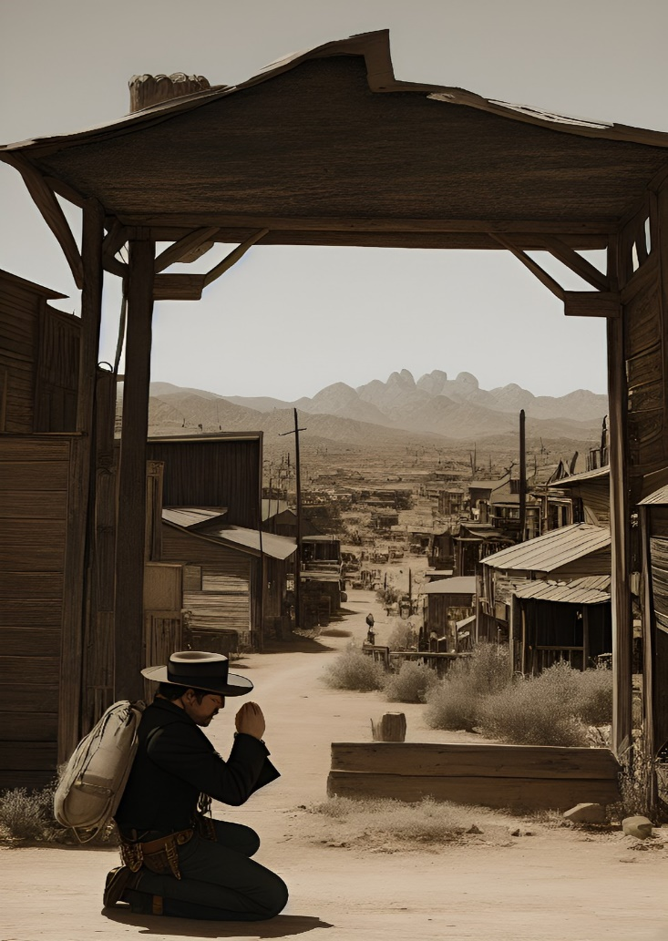

But then, something miraculous happened. The spirits of all the people who had died in the town appeared before him and thanked him for his sacrifice. They told him that his courage and selflessness had given them peace and that he had redeemed himself in the process.

Robert looked around in awe, feeling redeemed and at peace. He felt as though he had found his place in the world and that he had fulfilled his dream. He had saved the town, even if it had come too late.

Robert walked the dusty paths of the empty town, when suddenly, he heard a metallic clank. He stopped in his tracks and looked around. Nothing seemed to be out of the ordinary, but the noise had come from somewhere. He followed the sound until he reached the edge of town, where he was startled to see a strange portal of swirling colors and energy.

He cautiously stepped forward, and the portal opened to a new world. He stepped through it, and found himself in a lush forest, with trees as high as skyscrapers and colorful birds flitting to and fro. He realized he had been transported to a different universe, and he saw a small cabin in the distance. He walked towards it, and found a woman inside, tending to her garden.

She looked up at him, her eyes full of compassion. She explained that she was a traveler, like himself, and that the portal had sent her to this universe to help the people here who had been stricken with the same plague that had taken the lives of the Wild West town. She had been able to use her knowledge of healing to develop a cure, which she had been distributing throughout the universe.

Robert was overjoyed to hear this news, and knew that his sacrifice had not been in vain. He thanked her for her help, and asked if there was anything he could do to help. She told him that he could help by spreading news of the cure throughout the universe, and that he should tell the people to never give up hope.

Robert left the woman's cabin full of hope, and for the first time in a long time he felt a sense of purpose. He went around the universe, telling everyone he met of the cure and the hope of a better future. He felt a deep satisfaction that he had been able to save so many lives and make a difference in the universe.

And so, Robert's redemption was complete. He had saved an entire town and the countless lives of people throughout the universe, and he was at peace knowing he had done the right thing. He had finally found peace in himself.

# The Life Thief



John had been living what he thought was a perfect life. He had a great job, a loving family, and a beautiful girlfriend. Everything was going his way, or so he thought.

One day, while out running errands, he noticed that everyone around him seemed to be a bit off. They all seemed to know who he was, but none of them seemed to recognize him. John felt like he was being watched, like he was being judged by everyone.

He soon began to feel more and more uncomfortable, and decided to do some investigating on his own. He started to notice strange phone calls coming to his house, and conversations he was not privy to.

After doing some more digging, John realized that someone had been stealing his life. He had been replaced with a clone of himself, and that clone had been living his life while he was out of the picture. John was horrified.

He had no idea who could have done this to him, or how far their reach went. All he knew was that he had to get his life back. He had to find the person responsible and make them pay.

He started to follow the clues, and eventually tracked down the person who had been behind it all. It was his former friend, Lance. Lance had been jealous of John’s success and had decided to take everything away from him.

John confronted Lance and demanded that he give him back his life. Lance was scared and agreed to do so, but John knew he had to take more drastic measures. He contacted the police and reported Lance for what he had done.

Two weeks later, John got his life back. He was relieved, but also angry. He had been stolen from and he wanted justice. The police arrested Lance and brought him to trial, where he was convicted of identity theft.

John was a changed man. He was no longer the same person he was before his life was taken from him. He was now aware of his vulnerability, and would never take his life for granted again. He had realized that his life could be taken away in an instant. He now knew that he had to cherish every second, and make sure that no one ever took away something so precious from him again.



# A Magical Adventure to Sharm-el-Sheikh

My trip to Sharm-el-Sheikh with my girlfriend was an exciting and unforgettable experience. We had been planning it for months and were both really looking forward to it.

We flew from our home country to Cairo, and from there we took a bus to Sharm-el-Sheikh. The journey took about two and a half hours, and the scenery along the way was simply breathtaking. We stopped along the way to take pictures, and to admire the white sandy deserts and the distant mountain ranges.

When we arrived in Sharm-el-Sheikh, we were both amazed by the beauty of the city. The air was fresh and the turquoise water was simply stunning. We spent the first few days exploring the city and visiting different attractions. We also visited the local markets, where we got some amazing souvenirs to take back home with us.

One of the highlights of our trip was visiting the Red Sea. We took a boat ride and enjoyed the incredible marine life and scenery. We also did some snorkeling and we were able to spot some amazing coral reefs and colorful fish.

We also took the time to relax at the beach, and we enjoyed swimming in the warm sea and soaking up the sun. We also took some day trips to nearby villages and towns, and we enjoyed sampling their local cuisine.

At night, we would go out and explore the vibrant nightlife of Sharm-el-Sheikh. There were so many great bars and restaurants, and we had a lot of fun. We also got to experience some of the local culture, including a special Bedouin dinner and belly dancing show.

Overall, our trip to Sharm-el-Sheikh was an unforgettable experience. We had a great time exploring the city, indulging in the local cuisine, and relaxing by the beach. We also got to see some amazing sights, and enjoyed the culture and the nightlife. We both loved our time in Sharm-el-Sheikh and we would definitely recommend it to anyone looking for a unique holiday experience.



# A Dreamer's Journey: Find the Better Place



Ivan was born in a small rural village in the heart of Russia, surrounded by nothing but miles of untouched wilderness. He was born to a simple peasant family, living off the land and relying on the goodwill of their neighbours to get by.  
 It was a hard life, but Ivan was used to it. He had grown up in this tight-knit community, and was content with his lot in life. He enjoyed the simple pleasures that his life provided: going fishing with his father, playing in the nearby meadows, and helping his family with the work around their small homestead.  
 But Ivan had always been a dreamer. He loved to read, and often dreamed of one day travelling the world and seeing the things he had read about in books. When he was a young man, he was determined to make his dreams a reality.  
 He worked hard to save up enough money to make the journey, and in the summer of 2000, Ivan set off from his small village with nothing but the clothes on his back and a few possessions in a small bag. He had no specific destination in mind; he just wanted to escape the life he had been living for so long and see what the world had to offer.  
 Ivan was petrified at first, as he had never even been to the nearest city. But as he travelled further and further away, he began to relax. He made some friends along the way, and they shared stories of their travels and dreams. This gave Ivan the confidence he needed to continue his journey.  
 He eventually made it to the shores of the Baltic Sea. From there, he travelled to Germany, and then on to the United Kingdom. In the UK, he found himself a job as a hotel clerk, and eventually, a place to stay. He got himself a visa, and for the first time in his life, he felt secure and safe.

Ivan had finally made it, and he was determined to make the most of his new life. He worked hard and made a success of himself. He was able to eventually buy a house and even send money back to his family in Russia.  
 But while Ivan had made the most of his new life, he never forgot his roots. Every summer, he would travel back to Russia and visit the village of his birth. He would stay with his family and reconnect with his old friends.  
 His visits were bittersweet. On one hand, Ivan was happy to visit and see the village that had shaped him. But on the other, he was reminded of the life he had left behind. He was reminded of the fact that he had had to flee his homeland in order to make something of himself.  
 This was a feeling that Ivan had to live with, but he was determined to not let it define him. Despite the hardships, he had found a way to make something of himself in a strange new land.  
 He was proof that it was possible to make something of yourself, no matter where you were from. That was something that Ivan was determined to never forget.

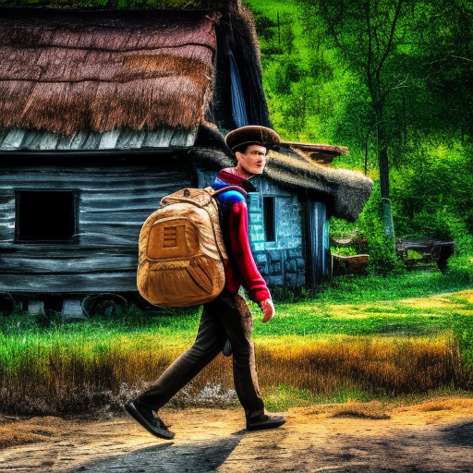

# D:\Downloads\dream_TradingCard_16.jpgSoul Master

Ilya was an unusual man. Born with an innate ability to see the souls of other humans, he could tell when someone was good or bad with a single glance. For centuries, he had used this ability to make a living by playing with the souls of other people.

He had a special deck of cards that represented the souls of those he encountered. He could play with them in any way he desired. He could make them happy or sad, angry or content. He could make them fall in love or fight with one another. He could even make them experience pain or pleasure.

There was a dark side to his abilities as well. He could take away the joy of a person’s soul and replace it with something sinister. He could possess souls and control them to do his bidding. He could even enslave them and use them for his own personal gain.

Many people were wary of Ilya and his an unusual power. They saw him as a demon or something from the shadows. But there were others who were intrigued by his abilities and sought him out for help.

One day an old man came to Ilya seeking his help. He told Ilya that his daughter had been taken by a man with a dark soul. He asked Ilya to help him find her.

Ilya agreed and began to play with the souls. He used his cards to feel out the souls of the people around him. After a few hours of searching, he finally found the man with the dark soul. He played with the man’s soul and made him reveal the location of the daughter.

The old man was filled with gratitude and gave Ilya a reward. He gave him an ancient box filled with rare objects. Ilya opened the box and found a set of golden cards. On the cards were symbols of power and knowledge.

Ilya soon realized that these cards were something special. He learned that they were the keys to unlocking the secrets of the Universe and manipulating the souls of humans. With these cards, he could do anything.

Ilya was filled with a new purpose. He dedicated his life to exploring the secrets of the Universe and manipulating the souls of others. He used his newfound power to help those in need and make the world a better place.

Ilya’s story spread far and wide. He was seen as a hero for his ability to play with human souls and make the world a better place. People from all walks of life sought him out for help and guidance.

Ilya’s legacy still lives on today. He is remembered as a man with a unique ability to play with human souls and make the world a better place. He is a symbol of hope and courage in a dark world.